Feature phone
# Source: Chatgpt (GPT-5-Mini) at [1/23/2026]
A feature phone is a basic mobile phone that provides essential communication features like calling and texting, without the advanced capabilities of a smartphone. It usually has physical buttons, a small screen, and limited apps or internet access.

Feature phone photo
# Source: Windows Screenshots (using Lightshot Program) at [1/23/2026]
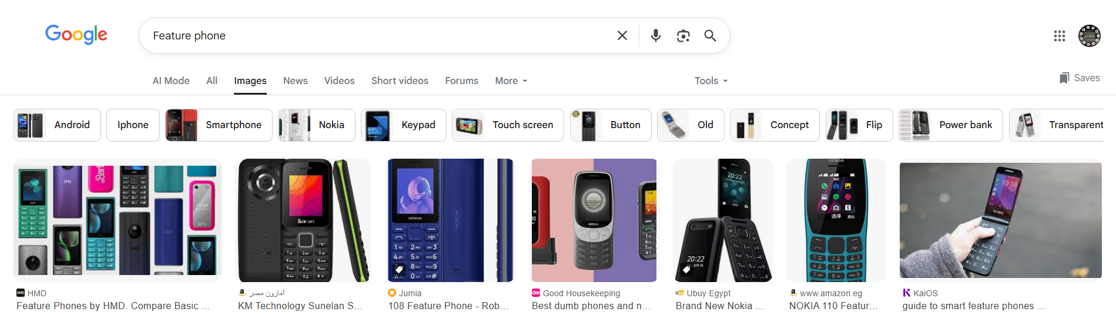

🔑 Key Features of Feature Phones:
# Source: Chatgpt (GPT-5-Mini) at [1/23/2026]
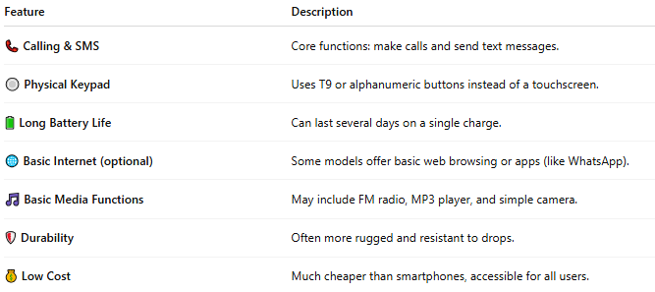

Feature | Description
📞 Calling & SMS | Core functions: make calls and send text messages.
🔘 Physical Keypad | Uses T9 or alphanumeric buttons instead of a touchscreen.
🔋 Long Battery Life | Can last several days on a single charge.
🌐 Basic Internet (optional) | Some models offer basic web browsing or apps (like WhatsApp).
🎵 Basic Media Functions | May include FM radio, MP3 player, and simple camera.
🛡️ Durability | Often more rugged and resistant to drops.
💰 Low Cost | Much cheaper than smartphones, accessible for all users.

📲 Examples of Feature Phones:
# Source: Chatgpt (GPT-5-Mini) at [1/23/2026]
- Nokia 3310 (Modern & Classic)
- Itel, Tecno, Lava, or Samsung feature phones
- JioPhone (India-specific with smart features)

📱 Feature Phone vs Smartphone:
# Source: Chatgpt (GPT-5-Mini) at [1/23/2026]
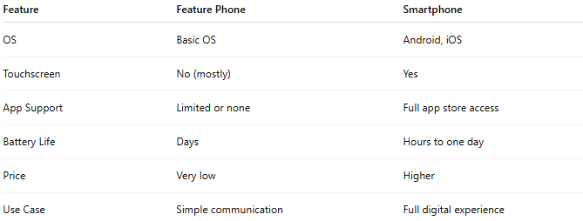

Feature | Feature Phone | Smartphone
OS | Basic OS | Android, iOS
Touchscreen | No (mostly) | Yes
App Support | Limited or none | Full app store access
Battery Life | Days | Hours to one day
Price | Very low | Higher
Use Case | Simple communication | Full digital experience

📖 Summary:
# Source: Chatgpt (GPT-5-Mini) at [1/23/2026]
A feature phone is a simple, affordable mobile phone mainly used for calling and texting. It's great for users who want basic functionality, long battery life, or a backup phone.

